

**MANIPAL INSTITUTE OF TECHNOLOGY**

(A constituent Unit of Manipal Academy of Higher Education)

# MANIPAL

**Drives, Controls and Modelling Laboratory Manual**

**(MTE 3161)**

Fifth Semester B.Tech (Mechatronics Engineering)

# NAME: Swaraj Dangare

# REG NO: 210929156

# ROLL NO: 37

|  |
| --- |
| Date: 21/ 09/2023 |

**Experiment III:**

**Open loop control of Controlled Rectifiers and Voltage Regulators**

**Aim:**

To simulate the open loop control of controlled AC-DC and AC-Converters.

**3-PHASE CONTROLLED FULL WAVE BRIDGE RECTIFIERS:**

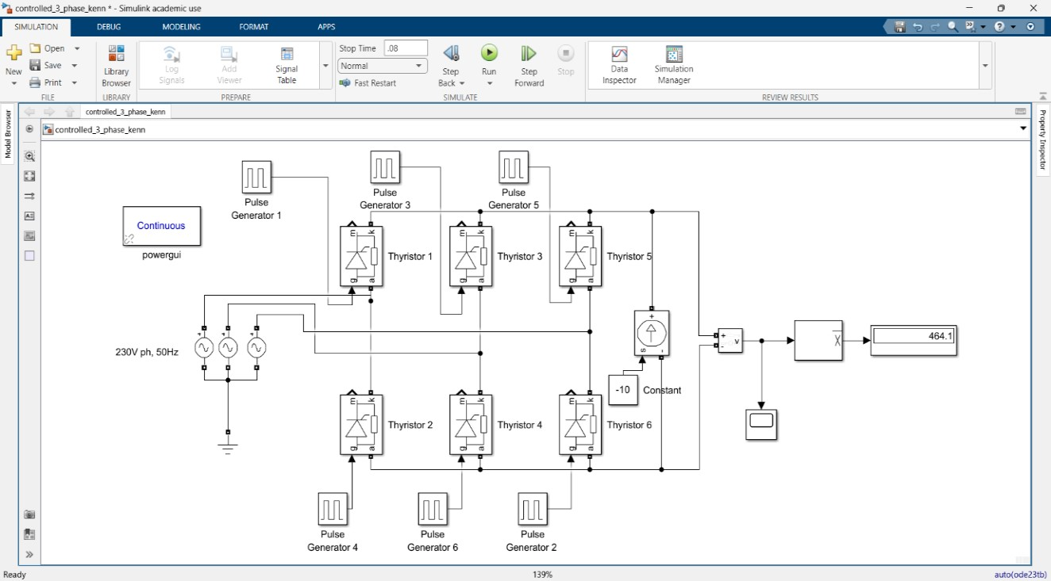

**210929156 Swaraj**

**Experiment IV:**

**Closed loop control of DC-DC Converters: Buck and Boost Converters**

**Aim:**

To simulate the closed loop Buck and Boost converters using **Simscape**

**Problem 1:**

Plot the voltage response of a closed loop Buck converter across a resistive load of 22 ohm. The source voltage is 220 V and PWM duty cycle is generated using PID controller block. Model the circuit with ideal switching devices and L = 100 ×10-3 H, C = 100 ×10-6 F and switching frequency 10KHz. Understand the significance of closed operation with fixed and step change in reference points.

## Closed loop DC-DC buck Converter

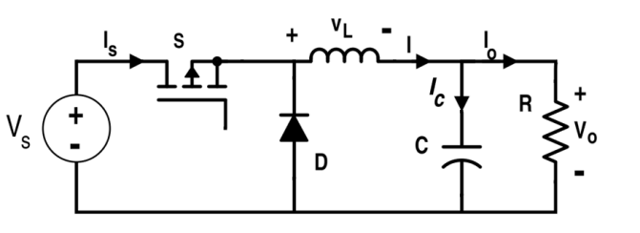

**Vout**

**Ref**

**+**

**-**

**Vout**

**act**

**PID**

**Duty cycle to PWM gate**

**Closed Loop Control Of Buck Converter With Fixed Reference Value:**

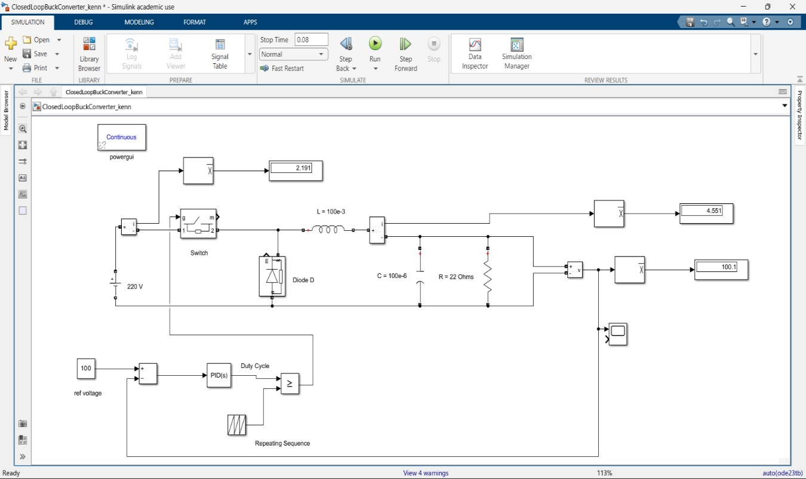

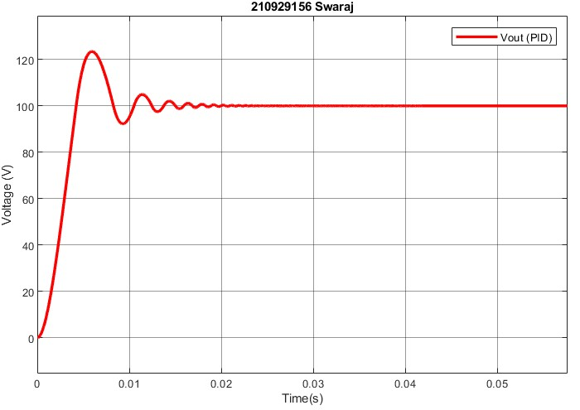

**Closed Loop Control Of Buck Converter With Step Change in Reference Value:**

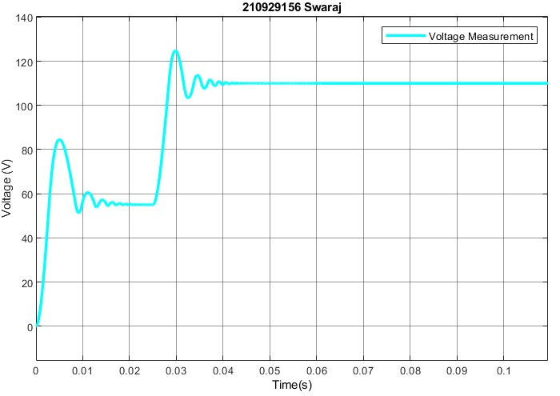

**Closed Loop Control Of Boost Converter With Fixed Reference Value:**

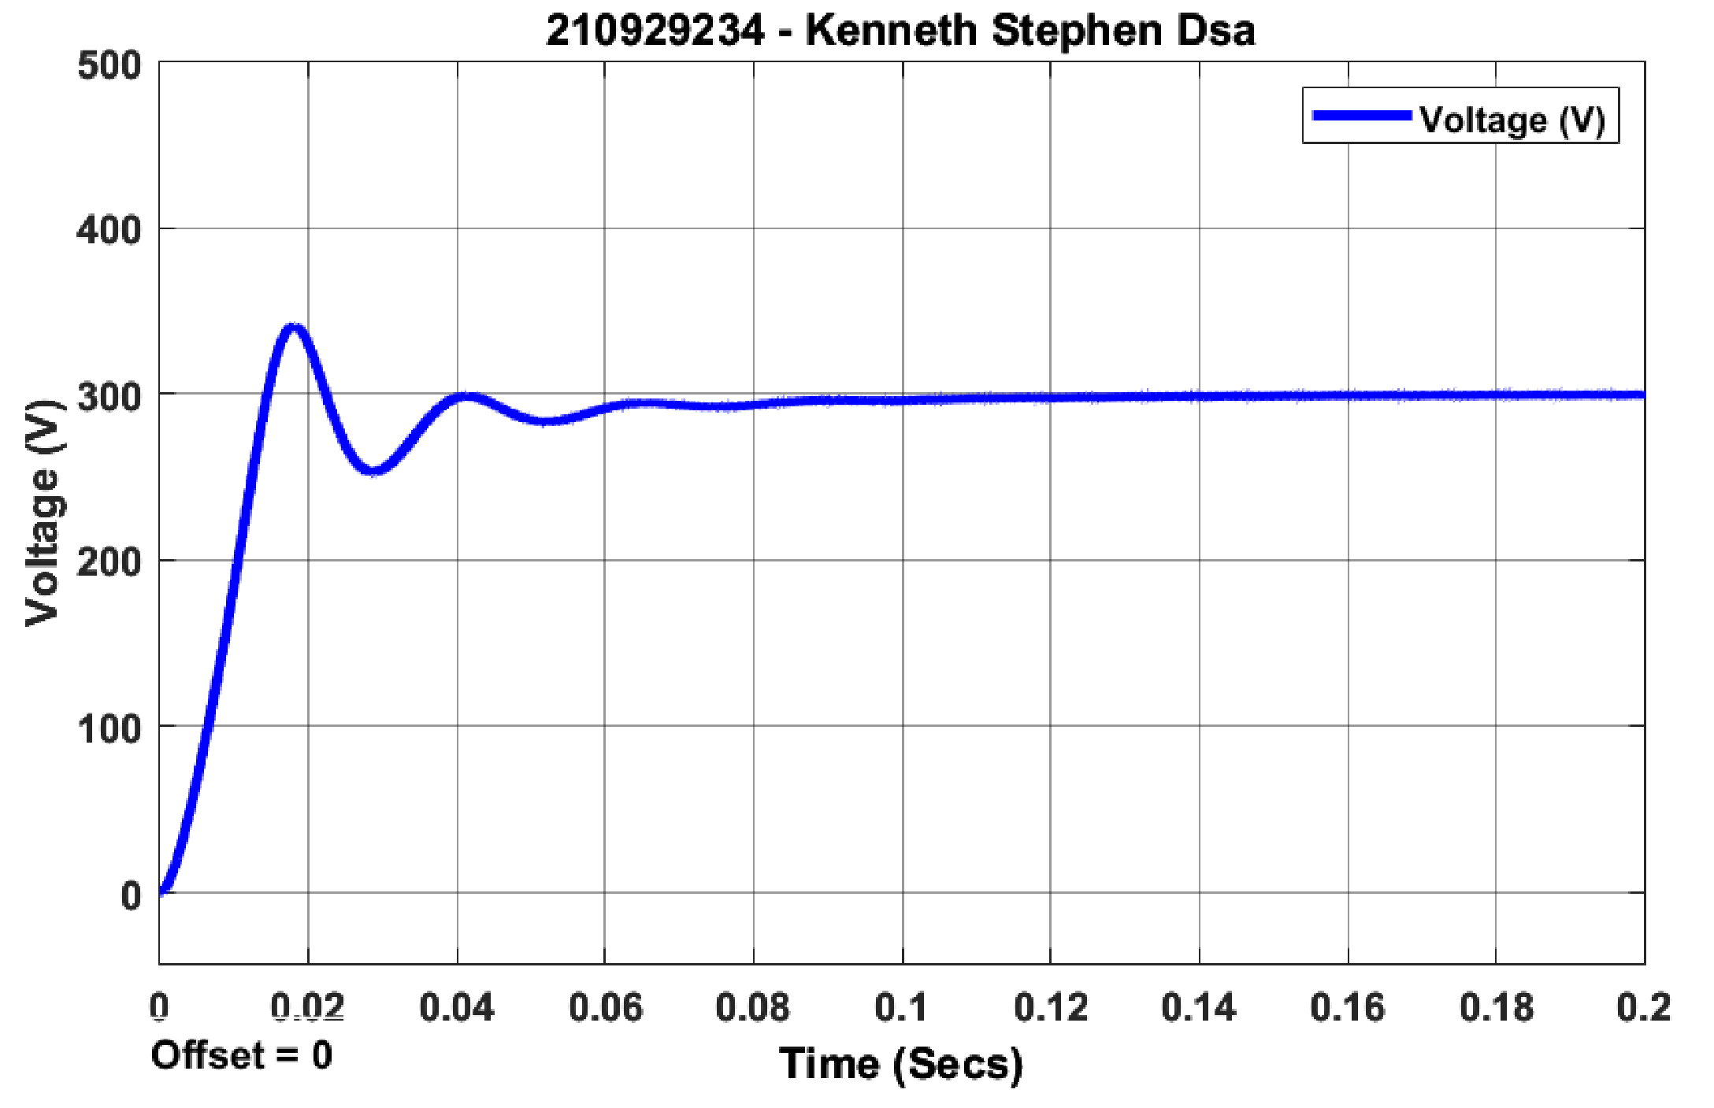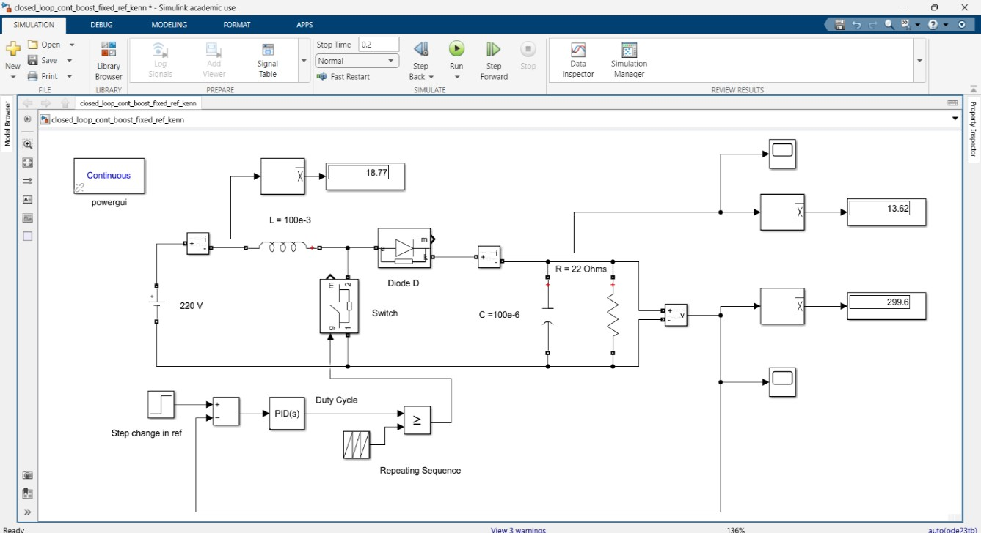

**210929156 Swaraj**

**Open-Ended Lab Exercises - 4:**

**1.** Describe open and closed loop control system and discuss when to select open loop and closed loop operation. Give some examples for open loop and closed loop systems.

Ans: **Open Loop Control:**

* No feedback loop; control action is based on predefined input.
* Simpler, cost-effective, but less accurate.
* Suitable for stable, well-understood systems with low precision requirements.
* Examples: Automatic washing machine (follows a fixed cycle), electric toaster (operates for a set time), traffic signal timing (fixed patterns). **Closed Loop Control:**
* Utilizes feedback to adjust output and maintain a desired setpoint.
* More complex and accurate, adapts to changing conditions.
* Ideal for systems with disturbances, uncertainties, or precise regulation needs.
* Common examples include thermostats, cruise control, and autopilots.
* Examples: Thermostat (maintains room temperature), cruise control (keeps constant speed), aircraft autopilot (controls flight parameters).

**Select Open Loop for:** Simplicity, cost-effectiveness, stable systems. **Select Closed Loop for:** Precision, adaptability, disturbance compensation, and critical applications. Many systems use a combination for optimal performance

**2.** Identify and discuss applications of PID Controller in Industry.

**Ans: PID (Proportional-Integral-Derivative) controllers** are widely used in various industrial applications for precise control of processes and systems:

1. **Temperature Control**: PID controllers regulate temperature in industrial ovens, furnaces, and HVAC systems, ensuring consistent and accurate temperature profiles.
2. **Chemical Processes**: They control variables like pressure, flow rate, and concentration in chemical reactors, ensuring product quality and safety.
3. **Manufacturing**: PID controllers are used in manufacturing processes to control parameters such as pressure, speed, and position in machinery and robotics.
4. **Water Treatment**: In water treatment plants, PID controllers manage the flow of chemicals, ensuring proper mixing and treatment of water.
5. **Motor Control**: PID controllers regulate the speed and position of motors in industries like automotive manufacturing and conveyor systems.
6. **Food Processing**: They control variables such as temperature and pressure in food processing equipment to ensure product consistency and safety.
7. **Energy Management**: PID controllers optimize energy usage by controlling heating, cooling, and power generation systems in buildings and factories.
8. **Biomedical Devices**: In medical equipment, PID controllers are used to control parameters like blood pressure, oxygen levels, and drug infusion rates.
9. **Agriculture**: PID controllers regulate parameters in farming equipment, such as irrigation systems, to optimize crop growth and resource usage.
10. **Wastewater Treatment**: They help manage the treatment process, ensuring effective removal of contaminants from wastewater.

PID controllers offer a balance between simplicity and effectiveness, making them essential tools in industrial automation and control systems across various sectors.

1. Discuss on advanced controllers used in Industries.

**Ans:** Advanced controllers like Model Predictive Control (MPC), Fuzzy Logic Control, Adaptive Control, and Neural Network Control are crucial in industries for optimizing complex processes. They offer precision and adaptability in applications ranging from chemical processes to autonomous vehicles. Robust Control, Cascade Control, H-infinity Control, and Fractional Order Control ensure stability and performance, even in uncertain environments. Supervisory Control and Data Acquisition (SCADA) and the Industrial Internet of Things (IIoT) provide real-time monitoring and data-driven optimization. These controllers are essential for efficiency, safety, and precision in diverse industrial settings, chosen based on specific application requirements.

1. Describe the effects of each controllers in PID.

**Ans: Proportional (P) Control**: The proportional component responds to the current error, which is the difference between the desired setpoint and the actual process variable. It generates an output signal that is directly proportional to this error. A higher P gain results in a stronger and faster response to errors, but it can lead to overshooting and instability if set too high.

* 1. **Integral (I) Control**: The integral component addresses the accumulated past errors over time. It calculates the integral of the error and applies a correction based on the area under the error curve. This helps eliminate any steady-state errors or biases in the system's response. However, excessive integral action can lead to oscillations and instability.
  2. **Derivative (D) Control**: The derivative component anticipates future error by looking at the rate of change of the error. It adds a corrective action based on the slope of the error curve, which helps dampen the system's response and prevent overshooting. Too much derivative action can lead to excessive noise amplification.

In summary, the proportional component provides an immediate response to current errors, the integral component eliminates steady-state errors, and the derivative component adds damping to prevent overshooting. Properly tuning these components in a PID controller is crucial for achieving a stable, accurate, and efficient control system in various industrial applications.

1. Recognize the disadvantages of PID controller and their mitigations.

**Ans:**

* 1. Overshoot and Oscillations: PID controllers can lead to overshoot and oscillations in the system response, especially when the proportional or derivative gains are set too high. To mitigate this, tuning methods like Ziegler-Nichols or trial-and-error can be used to find appropriate gains that balance stability and responsiveness.
  2. Integral Windup: Integral action can accumulate when the system is unable to reach the setpoint, causing overshoot or instability. Anti-windup mechanisms, such as clamping or resetting the integral term, prevent excessive integral action during saturation conditions.
  3. Non-linearity: PID controllers assume a linear system, which can lead to poor performance in nonlinear systems. Model-based or adaptive control techniques can be employed to handle nonlinearity more effectively.
  4. Delay and Lag: PID controllers do not account for time delays in the system, which can result in sluggish responses. Smith predictors or model predictive control (MPC) can be used to compensate for time delays.
  5. Sensitivity to Parameter Changes: PID controllers can be sensitive to changes in system parameters, requiring retuning if the system dynamics change. Adaptive PID control algorithms can adjust gains online to adapt to varying conditions.
  6. Robustness Issues: PID controllers may struggle in highly uncertain or rapidly changing environments. Advanced control techniques like robust control or fuzzy logic control can enhance robustness.